Abdul Latif Jameel Motors receives Toyota Excellence Award for 10th consecutive year to join prestigious ‘Outstanding Customer Service’ club

- Recognizing mutual success of a ‘Guest First’ ethos in car ownership and a 65-year partnership
- Abdul Latif Jameel is only the sixth Toyota distributor partner worldwide to receive the Award for 10 consecutive years

Tokyo, Japan –June 10, 2019
At a private ceremony held at the Toyota Kioi Club, in Tokyo, Japan on May 27, 2019, Mr. Mohammed Abdul Latif Jameel KBE, Chairman and Chief Executive Officer of Abdul Latif Jameel received a number of global awards from Toyota Motor Corporation (TMC), recognizing operational excellence in 2018. Foremost amongst these was the ‘Outstanding Customer Service Award’ for provision of exceptional service throughout the customer ownership experience.

This is the highest customer service commendation awarded by TMC to its worldwide distribution partners, and for Abdul Latif Jameel Motors Saudi Arabia, receiving the award for 2018, is a particular honor as it marks recognition for consistently providing outstanding customer service for ten consecutive years. Abdul Latif Jameel Motors is only the sixth TMC partner to achieve this, joining a dedicated group of partners who truly embody Toyota’s ‘Guest First’ philosophy; the other distributors being Canada, Taiwan, Thailand, Hong Kong and Kuwait.

During the same ceremony, Abdul Latif Jameel Motors Saudi Arabia was also awarded the second highest award for sales and marketing, for the second year running.

Toyota executives surprised the visiting delegation from Abdul Latif Jameel by wearing traditional Saudi Arabian national dress to honor the long-standing partnership.

Presenting the awards, Mr. Nobuhiko Murakami said: “Through our 65-year partnership with Abdul Latif Jameel we have established a tight and enduring relationship, based on a spirit of mutual trust and a firm belief in the Toyota way. We appreciate Mr. Jameel’s strong leadership and achievement over the years - today and future - and look forward to the coming 65 years of success together.”

Accepting the awards, Mr. Mohamed Jameel gave thanks and said: “Really, this award is not solely for Abdul Latif Jameel; this award recognizes the combined efforts of the Abdul Latif Jameel-Toyota team together in the service of our ‘guests’. We share the philosophy of Toyota and make it our guiding light always: driving continuous improvement through Kaizen practices and placing our customers, as our ‘guests’, at the center of everything we do. I look forward to what we will learn together in the future.”

The event was attended by TMC executives, Mr. Nobuhiko Murakami, Operating Officer & Chief Executive Officer, East Asia, Oceania & Middle East Region; Mr. Akitoshi Takemura, General Manager of Middle East & Central Asia Division; Mr. Shingo Sasaki, General Manager of Parts Operations Division (representing Customer First Promotion Group) along with executives from MECAD including ALJ ICT and Service division from Nagoya. It was also attended by Mr. Shigeki Enami, (榎並滋喜) President and Chief Executive Officer, Abdul Latif Jameel General Trading Co. Ltd, Japan and Mr. Tsuyoshi Mizutani from Abdul Latif Jameel Motors.

Abdul Latif Jameel Motors has been a proud partner of Toyota Motor Corporation for nearly 65 years, originally appointed to represent Toyota in Saudi Arabia in 1955.

- ENDS -

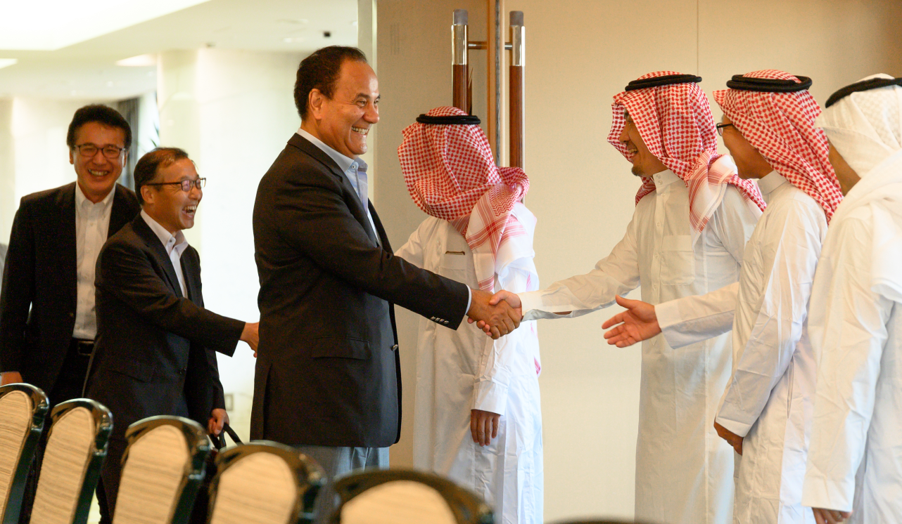
The moment of surprise as Mr. Jameel is greeted by Toyota Motor Corporation Executives in Saudi Arabian national dress.

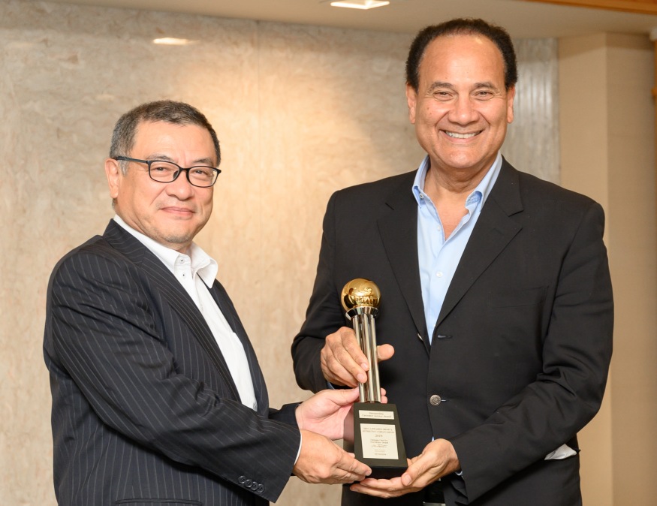
Mr. Shingo Sasaki, General Manager, Parts Operations Division, TMC presents the ‘2018 Outstanding Customer Service Award’ to Mr. Mohammed Jameel, Chairman and CEO, Abdul Latif Jameel.
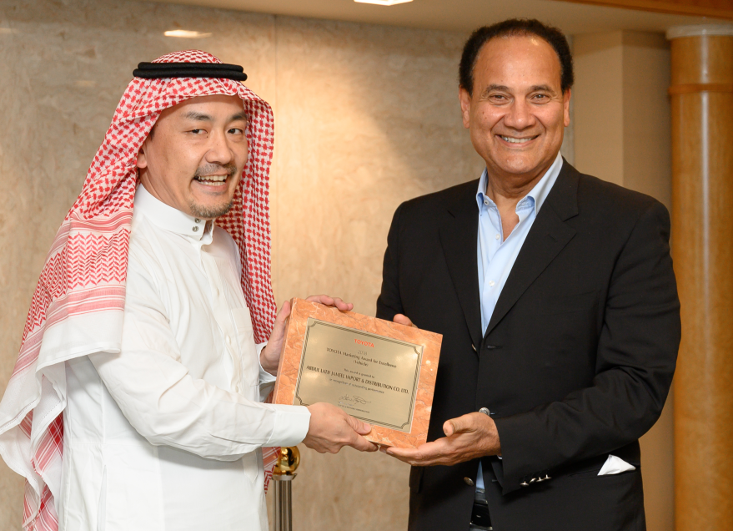
Mr. Akitoshi Takemura, General Manager, Middle East & Central Asia Division, TMC presents the ‘2018 Marketing Award for Excellence’ to Mr. Mohammed Jameel, Chairman and CEO, Abdul Latif Jameel.

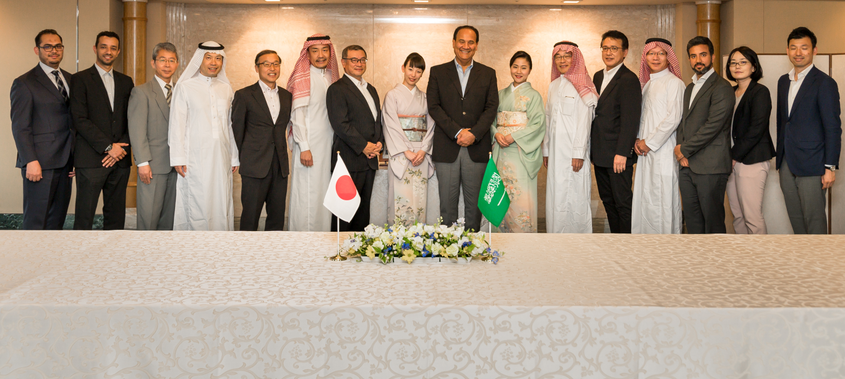
The Toyota Motor Corporation and Abdul Latif Jameel representatives at the awards ceremony at the Toyota Kioi Club, in Tokyo, Japan on May 27, 2019

About Abdul Latif Jameel
Abdul Latif Jameel refers broadly to distinct separate and independent legal entities whose interests encompass automotive distribution, auto parts manufacturing, financial services, renewable energy, environmental services, land and real estate development, logistics, electronics retailing and media services. Abdul Latif Jameel positions itself as a preferred business partner primarily for inward investment into the Middle East, North Africa and Turkey (MENAT) region.
For more information, please visit: www.alj.com

About Abdul Latif Jameel Motors
Abdul Latif Jameel Motors is a leading independent automotive distributor and retailer in Saudi Arabia representing a number of global automotive brands, including Toyota since 1945, and Lexus since 1989. Abdul Latif Jameel Motors offers full brand representation, including wholesale, marketing, sales, servicing, personalization of vehicles and spare parts manufacturing.

Through its extensive network across the country, Abdul Latif Jameel Motors provides seamless distribution and world-class service and maintenance, with over 435 state-of-the-art facilities and showrooms, including the world’s largest Lexus facility, and a highly qualified workforce of Associates.
For more information, please visit: www.alj.com/en/transportation or www.toyota.com.sa

Media Inquiries:
For more information, please email us at media@alj.ae or call +971 4 448 0906 (+4 GMT - Dubai, UAE).

Disclaimer:
© Abdul Latif Jameel Company Limited. All rights fully reserved. The Abdul Latif Jameel name, and the Abdul Latif Jameel logotype and pentagon-shaped graphic are trademarks, or registered trademarks of Abdul Latif Jameel IPR Company Limited.

The term “Abdul Latif Jameel” refers broadly to several distinct, separate and independent legal entities. Abdul Latif Jameel is not itself a corporate entity, association or conglomerate run by an overarching parent company but merely refers to a group of distinct and wholly separate legal entities that are collectively referred to as Abdul Latif Jameel. Abdul Latif Jameel is not a corporate group as defined in section 1161(5) of the Companies Act 2006.

This website may contain forward-looking statements. Forward-looking statements are statements regarding matters other than historical fact, such as future results, events, activities, developments or circumstances or the beliefs, plans or expectations of Abdul Latif Jameel entities or their respective managements. Forward-looking statements often can be identified by the use of words such as ‘expect’, ‘project’, ‘anticipate’, ‘plan’, ‘estimate’, ‘believe’, ‘predict’, ‘intend’, ‘potential’, ‘possible’, ‘probable’, ‘likely’, ‘forecast’, ‘guidance’, ‘outlook’, ‘goal’, ‘target’, ‘may’, ‘will’, ‘should’ or ‘could’ or other similar terms or phrases. However, the absence of such words does not mean that a particular statement is not forward looking.

Forward-looking statements are based on expectations and assumptions at the time of such statements and are subject to numerous risks and uncertainties, many of which are outside the control of Abdul Latif Jameel entities. Should any of such expectations or assumptions prove incorrect, or should any of such risks or uncertainties materialize, actual future results, events, activities, developments or circumstances may differ materially from those expressed in or implied by forward-looking statements. Further, any forward-looking statement speaks only as of the date on which it is made, and Abdul Latif Jameel do not assume, and hereby disclaims, any obligation to correct or update any forward-looking statement, whether as a result of new information, future events or otherwise.

All forward-looking statements made by Abdul Latif Jameel, or by any person on behalf of any of them, whether communicated in writing, electronically or orally, are qualified in their entirety by the foregoing cautionary statements.

